**Francis Hobart Hemery**

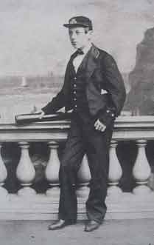

https://www.theislandwiki.org/index.php/File:Francis-Hobart-Hemery.jpg

Francis Hobart Hemery was born at sea on the 22nd March 1847, the son of John and Anna Hemery (nee Beatty). He was baptised in Jersey on the 12 May.

He joined the navy in [ ] was appointed sub lieutenant on 11 September 1860. (NA - ADM 196/17/58) and in the 1861 census he is a naval cadet. He was assigned to *H.M.S Achilles*, a broadside ironclad frigate which defended the waters of the English Channel as part of the Channel Fleet, as a sub-lieutenant on the 5 June 1867. The Captain was E.W. Vansittart.

Francis was invalided two years later on the 30th April 1869. He was reported fit for duty three months later on the 2nd August and joined the crew of *H.M.S Inconstant* on the 12th of that month, once again as part of the Channel Fleet. Two months later on the 14th October, he was sent to Haslar Hospital per *H.M.S. Helicon* for “general mania”. He was discharged from the hospital on the 7th May 1870, after a six and a half months stay. General mania was defined by William Augustus Guy in his *Principles of Forensic Medicine* in 1845 as “a form of mania which affects both the intellect and the passions, and throws the whole mind into a state of mingled excitement and confusion.” It was characterised by Pinel as a “rapid succession of uninterrupted alternation of insulated ideas, and evanescent and unconnected emotions” as well as by an “abolition of the faculty of judgement.” It was clear that Francis was unfit for the responsibilities placed upon him.

On release from hospital, Francis was assigned to *H.M.S Duke of Wellington*, the flagship of the Port Admiral at Portsmouth, four days later on the 11th. The flagship fired salutes to passing dignitaries such as Queen Victoria on her way to Osborne House. It was clearly a softer option for a man who was seen as lacking judgement. Three months later on the 10th August, he was sent to *H.M.S. Repulse,* a guardship at Queensferry, for temporary service, returning to the *Duke of Wellington* on the 21st October. On the 15th March in the following year, he was assigned to *H.M.S Danae*, when recommissioned, taking a passage out to North America in *H.M.S Himalaya.* He is recorded in the census in Devonshire.

His time on the *Danae* was to be short and after thirteen days he was sent home unfit. On the 17 November 1871 he was deemed to be unfit and ten days later was granted 2/6 (home pay?) . He was retired from the navy on the 20 February 1872.

Francis H. Hemery’s poetry anthology *The Soul Speaks and Other poems* was published by Samuel Tinsley in 1874. Samuel Tinsley published 25 titles this year including poetry anthologies by

He published poetry throughout 1875, 1877, 1878 and 1879 in *The New Monthly Magazine*, *St James’ Magazine, Tinsley’s Magazine* and *Bow Bells.*

In September 1875, he was living at 61, Chelsea Place, St Helier’s Jersey.

Hemery was a member of the Persistent Scribblers Society from c. July 1875 (check May 1875 book) – July 1876. His sisters Kate and Leonora also joined the society.

His address for July 1876 is given as Barton Fields, Canterbury, his parents address.

His father John wrote to the navy in 1875, 1876 and 1878 requesting that Francis not be allowed to commute.

c. August 1878, Francis had a mental breakdown and was admitted to Dr Boyd’s private asylum.

Francis died on the 25th April 1879 at Uxbridge aged 31, having committed suicide.[1]

During 1875-1879, the period when we know that Hemery was active, *The New Monthly Magazine* featured (how many poems) of which 35 included the word ‘sea’.

Note A VISION OF LIFE. NEMO.The St. James's magazine; London Vol. ser.4. 35, (Jun 1879): 505-505.

Words for Music. Under the trees. NEMO. Musical standard; London Vol. 15, Iss. 746, (Nov 16, 1878): 307-307.



Hemery, Francis H. Tinsleys' magazine, 1867-1892; London Vol. 22, (May 1878): 537-537.

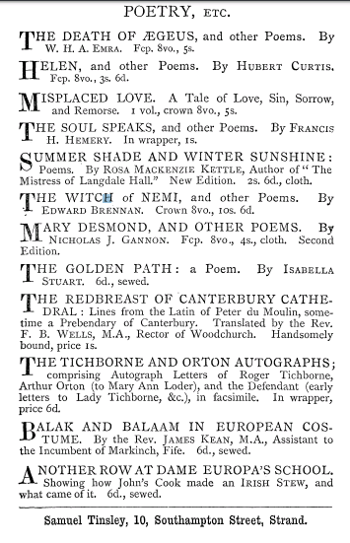

p.434 of Italy Revisited by A. Gallenga.

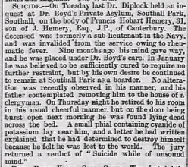

May 3 1879 Whitstable Times and Herne Bay Herald

Private lunatic asylum

Rheumatic fever is a very rare complication that can develop after a bacterial throat infection. It can cause painful joints and heart problems. Most people make a full recovery, but it can come back. (NHS Direct)

Read Mid-Victorian Poetry 1860-1879 by Catherine Reilly.

1. <https://www.theislandwiki.org/index.php/Francis_Hobart_Hemery>

   * This photograph is of Francis Hobart Hemery one of the original members of the society. His father John Hemery, was mayor in 1879 and his sisters Kate and Leonora are active members. Francis published an anthology of poetry entitled *The Soul Speaks and Other poems* in 1874, a year before the society was established.
   * His poems appear in Tinsley’s Magazine, The Argosy, the New Monthly Magazine, and St James’s Magazine.
   * Sadly Hemery contracted rheumatic fever, and was medically discharged from the navy He committed suicide in a private mental aslyum in 1879.
   * His poem Disregarded written in 1877, may give us an indication of his mental state. The theme of death pervades all this poetry and one gets the sense that a woman he loved has died and he is mourning her.

   **Literary Connections**

   Francis Hemery enjoyed some success in the pages of (which magazine) which was edited by Harrison Ainsworth (is this correct) Ainsworth, considered one of the ‘gallows’ school wrote sentimental defences of felons cruelly treated by harsh sentencing, his empathy for the villain has a Gothic flavour (evidence and then FN p188 Bloom – and do I agree with this?)